Privacy Detailed Information Notice
Request for Information

 | Why should you read this notice?
You have the right to understand how your information is being used. We will make sure you get all the information you need to do so.

 | Who are we?
The Saint-Gobain Glass entities (hereinafter “Saint-Gobain Glass”) are companies of the Saint-Gobain Group (“Group”) involved in the glass business. Whenever dealing with one of the Saint-Gobain Glass entities (hereinafter “Entity”), the controller of your personal data will be the Entity that decides why and how your personal data is processed.
In this policy the terms ("we", "us", "our") refers to the particular Entity that is the controller of your personal data.

Saint-Gobain Glass France is in charge of this notice.
Saint-Gobain Glass France
Tour Saint-Gobain
12, Place de l’Iris
92400 Courbevoie

 | Why do we process your data?
We collect and process your data to contact you following your request for information. To be more precise, we have the following purposes:
- Request for information
- Producing statistics and reports

 | On what grounds do we process your data?
We collect and process your data on the following basis: A legitimate interest

The legitimate interest pursued by the controller is necessary to contact you following your request for information.

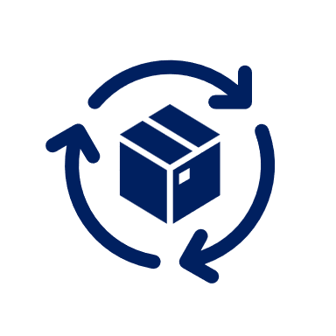 | What data, where it comes from and how long we keep it?
Data categories |  | Data source | Retention period
First name, last name, job title, company, professional email, professional telephone number, country |  | Direct source | No later than 3 years from the date of your request

 | What happens if you do not provide your data?
The data processing cannot be carried out if you do not provide the following data:
- First name, last name, job title, company, professional email, professional telephone number, country

 | With whom do we share your data?
When we process your data, we share it with the following categories of recipients:
- Commercial and marketing departments of the Entity which will contact you to respond to your request for information
- Commercial and marketing departments of the Entity’s affiliates
- Audience analysis service
- The Service Provider who helps us develop and maintain our internet website and its subprocessors

 | Is there an international transfer of the data?
Personal data may be transferred outside the European Union, notably in the United States. Safety and confidentiality of these transfers are contractually guaranteed by the application of the standard contractual clauses elaborated by the European Commission.

 | What are the rights you can exercise?
The regulations may allow you to exercise the following rights concerning your personal data:
  - Right of access;
  - Right to rectification;
  - Right to erasure;
  - Right to restriction of processing;
  - Right to object;
  - Right to data portability;

There may be situations where we cannot grant your request, but we will of course explain why — for example, if you ask us to delete your data and we are legally obligated to keep a record of that data to comply with law.

 | How to get in touch with us
We want you to feel confident that we look after everyone’s personal data in line with the law. If you have any questions about your rights in the context of the processing activity, you can get in touch with us:
- by email at : privacycontact.sgglassfrance.fr@saint-gobain.com
- by post at : Saint-Gobain Glass France
Legal department – Privacy Correspondent
12, place de L’Iris – Tour Saint-Gobain
92400 Courbevoie

 | How to complain
If you consider, after contacting us, that your rights are not respected or that this data processing does not comply with privacy rules, you have the right to lodge a complaint with the competent supervisory authority.

 | Additional information
In France, we remain that individual benefit of the right to define guidelines on the fate of his or her personal data after death.

To consult at any time the information related to Your data and your rights, go to our website where the privacy-related documentation, and notably the Saint-Gobain Glass’s Privacy Policy, is available for the data subjects.

